DAP Wallet Infrastructure – Architecture Review & Recommendations (Draft v0.1)
Oct 7, 2026 · @Rahul Pandey

Purpose and scope
The DAP design is directionally strong; the biggest gains now come from consolidating policy enforcement, binding intent to signed bytes, abstracting the custody vendor, and hardening the event/ledger path before scaling to more BUs, chains and agentic clients.
This is an initial draft for discussion, based on the DAP Overall Architecture Confluence page (last updated Sep 25). It covers: my reading of the design, what it gets right, 15 findings with recommendations, a target-state architecture, and a question list for the team. Findings are framed as hypotheses to validate, not conclusions.
Interpretation note — "MCP wallets". The term is used two ways in the industry, and both matter here:
- MPC wallets (multi-party computation): keys split into shares, signed via threshold protocols. DAP already uses this via Fireblocks MPC-CMP workspaces and an MS-hosted API Co-Signer. Covered in the MPC deep-dive.
- MCP wallets (Model Context Protocol): AI agents reaching wallet capabilities through MCP tool servers. Not in the current design; covered as a proposed access layer.
If the team means only one, the other section can be dropped.

My understanding of the current design
DAP is a multi-tenant custody and on-chain execution platform: BUs (WM, ISG, IM) call a blockchain-agnostic API, Core DA Services translate business intent into blockchain-aware calls, and a sharded Base Platform drives Fireblocks MPC signing onto EVM, Solana and Canton.

Layers
Layer | Components | Contract it exposes
BU DAMO (WM / ISG / IM) | Middle office: client mgmt, funding, trade execution/settlement, P&L | Calls DAP with acct/asset, token spec, mint/burn/transfer; receives status
Core DA Services | Tokenization, On-chain Settlement, Staking, Lending, Borrowing, Trading, X-Region | Blockchain-agnostic API upward
Base Platform (per shard) | Token, Wallet, TX, Policy, Callback Handler, Co-Signer (inside a workspace); Smart Contract, Event, Screening, Oracle services | Blockchain-aware API (CRUD wallet/token/tx/policy/contract/oracle) + status/event/callback feed
Platform control plane | X-Tenant Routing, Platform Registry, Tenant Service, IAA/IAM, Key Service/HSM, Admin Portal, Platform Fee Service, Monitoring | Tenant onboarding, routing rules, roles and API keys
Edge | Ingress (webhooks in), Egress (vendor API out) | Vendor isolation boundary
Vendor + chains | Fireblocks cloud (API GW, Signing Engine, Webhooks); EVM, Solana, Canton, smart contracts | Custody, MPC signing, broadcast

Domain model (as I read the class diagram)
- Business Unit owns 0..n Shards; a shard maps 1:1 to a vendor Workspace (HSM or MPC variant).
- Workspace → Vault Acct → Asset Wallet (one per asset, account- or UTXO-based) → Address (EOA derived from a public key, or contract address derived from deployment).
- Wallet is a DAP-level grouping/layering concept tagged to an Account (omnibus, segregated, issuer, admin, gas-station).
- Token (ERC-20, ERC-3643, …) is supported by a Smart Contract deployed on a Blockchain.
- Policy attaches at shard (business/platform) and workspace (vendor TAP) levels; Quorum of Approver/API_User; Co-Signer configured with a KeyShare; Gas Station funds native assets.

Key flows I traced
- Business onboarding — onboard request → approve → create api-keys (IAA) → create custodian → create Fireblocks workspace → MPC key ceremony with API Co-Signer (MS-POLICY-CHECK, key share possibly HSM-backed) → instantiate shard with staging/prod silos → set biz policies → enable ingress/egress proxies and co-signers → update custodian routes → return api-keys and entry points.
- Tenant-aware routing — BU sends api-key + signed platform intent → X-custodian Routing resolves biz-id → shard-id → entry point → forwards to service(i)@shard.
- Tokenization end-to-end — TOKEN_ONBOARDING (create platform intent, tag by biz-id, check biz policy, create token record, set token policy) → optional VAULT/WALLET CREATION → optional CONTRACT-DEPLOY (policy + security check, deploy via TX-EXECUTION) → optional TOKEN_UPDATE → mint/burn/transfer via TX-EXECUTION.
- Omni-wallet creation — platform intent → Wallet Service@X checks business policy, sets vault/wallet policy → Fireblocks creates vault/wallets (TAP check, whitelist) → event → status.
- On-chain transaction end-to-end — three MS-POLICY-CHK gates: /business-policy (Wallet → Policy Engine → Policy Approver, signed verdict), /platform-policy (TX Service, signed dap-verdict), and /signing-policy (Co-Signer callback checks ref_id ↔ platform-intent ↔ Ti ↔ Tr match, gas range, Tr = signing payload, biz policy) → partial sig → Fireblocks full sig → broadcast → DATA-EVT-FEED and TX-STATUS-FEED → holdings updated.
- Cross-shard settlement — resolve both tenants via Platform Registry, fetch to-shard deposit address, set a one-time whitelist on the from-shard policy, then transfer.

Wiring protocol
Every message is a typed protobuf payload plus a 5-field header channel (x-dap-version, x-dap-service, x-dap-msgtype, x-dap-api-key JWT, x-dap-msg-sig RS256 detached over canonical proto bytes), carried as gRPC metadata, HTTP headers, or Kafka PayloadHeaders.referenceIds. Bytes are relayed verbatim and verified at both the dispatcher edge and the destination.

What the design gets right
The foundations are enterprise-grade: hard tenant isolation, defense-in-depth signing, and a transport-neutral message contract are the hardest things to retrofit, and DAP has them from day one.
- Two-API layering. Separating a blockchain-agnostic API (business intent) from a blockchain-aware API (wallets, tx, contracts) is the right seam. New chains change the lower layer only.
- Shard-per-BU isolation. Each BU gets its own workspace, keys, policies and co-signer. Blast radius of a compromised API key or bad policy is one BU, which maps well to Chinese-wall and entitlement requirements.
- Bank-controlled co-signer. An MS-hosted API Co-Signer with a pre-signing callback means Fireblocks alone cannot move assets. This is the key control that makes a SaaS MPC vendor acceptable to risk.
- Signed policy verdicts. Verdicts carry ref_id, policy_ref, reason, conditions and a signature, so every approval is attributable and replayable for audit.
- Correlation by ref_id. One id from platform intent through Ti, Tr, txid and events gives end-to-end lineage.
- Detached message signatures over verbatim bytes. Avoids the protobuf non-canonical re-marshal trap and lets a payload-opaque dispatcher verify at the edge (fail fast) and the destination (zero trust).
- Explicit finality handling. The tx flow names execution, reorg and finality revision, which many first designs ignore.
- Cloud-neutral, containerised, event-driven. HPA/KEDA autoscaling without serverless lock-in keeps deployment options open across on-prem and cloud.

Design feedback and recommendations
Five findings are high priority because they touch asset safety or auditability: policy fragmentation (F1), intent-to-bytes binding (F2), message-signature scope (F3), ledger source of truth (F5) and co-signer availability (F9).
# | Finding | Area | Priority
F1 | Four policy checkpoints with no single decision model | Policy | High
F2 | Co-signer must prove signed bytes = approved intent (WYSIWYS) | Signing | High
F3 | Message signature covers payload but not routing headers; no replay window | Wiring protocol | High
F4 | Event path needs outbox, idempotency and per-chain finality states | Eventing | Medium
F5 | Holdings updated in both Token and Wallet services | Ledger | High
F6 | Domain model mirrors Fireblocks concepts; vendor lock-in | Custody abstraction | Medium
F7 | Platform Registry sits on every hot path | Routing / scale | Medium
F8 | Cross-shard transfer is two-step, not atomic | Settlement | Medium
F9 | Co-signer is a liveness dependency on every signature | Key mgmt / HA | High
F10 | Screening, KYT and Travel Rule placement unclear | Compliance | Medium
F11 | Admin-portal actions may bypass the intent pipeline | Governance | Medium
F12 | Smart-contract upgrade and role governance not specified | Contracts | Medium
F13 | Throughput limit is vendor API + MPC latency, not pods | Scale | Medium
F14 | Gas, nonce and fee-sponsorship strategy | Execution | Low
F15 | Reconciliation and audit lineage not yet drawn | Ops / audit | Medium

F1 — Consolidate policy into one decision model
Today a transfer passes /business-policy, /platform-policy, /signing-policy and Fireblocks TAP. Each re-evaluates partially overlapping rules, so the same intent can get different answers (policy drift), and rules evaluated at t0 may be stale by signing at t1 (TOCTOU).
Recommend:
- One Policy Decision Point (PDP) with versioned, signed policy bundles authored as code (OPA/Rego or AWS Cedar), with a separate Policy Administration Point and 4-eyes on bundle changes.
- Each gate evaluates a different input stage (intent → built tx → raw tx) against the same bundle, and emits a decision token: {ref_id, stage, H(input), bundle_version, verdict, obligations, exp} signed by the PDP.
- The co-signer verifies the chain of decision tokens and that H(Tr) matches, rather than re-deriving business rules. Re-evaluate only time-sensitive rules (limits, sanctions) at signing.
- Generate the Fireblocks TAP from the same bundle so the vendor layer is a mirror (defense in depth), not a separately maintained rulebook.

F2 — What-you-see-is-what-you-sign at the co-signer
The co-signer check "Tr matches signing payload" is the last line of defense. The 2025 Bybit loss showed that a manipulated payload behind a trusted signing UI defeats multisig and MPC alike.
Recommend:
- An independent transaction decoder in the co-signer that does not trust vendor-parsed fields: EVM RLP/EIP-1559 + ABI calldata decode, EIP-712 typed-data decode, delegatecall and approve/permit detection; Solana instruction + address-lookup-table decode; Canton command/transaction view decode.
- Pre-sign simulation (forked eth_call / simulateTransaction) producing expected balance deltas, then assert deltas = intent (asset, amount, counterparty) within tolerance.
- Allow-lists keyed on (chain_id, contract, function selector); deny unknown selectors by default; cap approve allowances.
- Sign the decoded "human view" into the audit record so approvers and auditors see what was actually signed.

F3 — Tighten the wiring-protocol signature
x-dap-msg-sig covers payload bytes only. x-dap-service and x-dap-msgtype are unsigned, so a valid signed payload could be replayed or re-routed to a different handler if two message types share a compatible schema. There is also no timestamp, nonce or audience.
Recommend:
- Sign a canonical signature base in the style of HTTP Message Signatures (RFC 9421): version ‖ service ‖ msgtype ‖ kid ‖ created ‖ nonce ‖ aud ‖ SHA-256(payload).
- Add x-dap-created, x-dap-nonce (doubles as idempotency key) and x-dap-aud; reject outside a ±N s window; keep a nonce cache per kid.
- Consider Ed25519 or ECDSA P-256 over RS256: ~64-byte signatures vs 256, faster verify, HSM-friendly.
- Kafka supports native record headers; prefer them over overloading PayloadHeaders.referenceIds unless the wmBaseEvent envelope mandates it.
- Layer, don't replace: mTLS with workload identity (e.g., SPIFFE/SPIRE) for service-to-service authN; the message signature then serves non-repudiation of business intent.

F4 — Exactly-once effects on an at-least-once bus
Event Service fans out, correlates and re-publishes; balances update "if TX confirmed". Without explicit guarantees this produces duplicate credits or lost status under retries.
Recommend:
- Transactional outbox (or CDC) in every service that emits events; consumers use idempotency tables keyed on (ref_id, event_type, seq).
- Partition Kafka by (tenant, vault_account) so per-account ordering holds.
- Explicit per-chain finality state machine: INTENT → APPROVED → SIGNED → BROADCAST → INCLUDED → SAFE → FINALIZED, with REORGED / DROPPED / REPLACED branches. EVM: use safe/finalized block tags; Solana: confirmed vs finalized commitment.
- Multi-step workflows (tokenization's optional steps, onboarding) run as sagas with compensations, ideally on a durable workflow engine (e.g., Temporal) instead of hand-rolled state in each service.

F5 — One ledger, many projections
Both Token Service and Wallet Service "update holdings". Two writers to balances guarantees divergence eventually.
Recommend: a single append-only double-entry sub-ledger (event-sourced) that is the only writer of positions; Token/Wallet views become read projections. Separate pending (reserved on approval) from settled (on finality) balances, and post reversal entries on reorg instead of mutating history. This also feeds Back Office Books & Records directly.

F6 — Custody provider abstraction
The model's Workspace, Vault Acct and TAP are Fireblocks nouns. The cross-shard diagram already shows "Custody Vendor (A)" and "(B)", so multi-vendor seems intended.
Recommend: a Custody Provider SPI (anti-corruption layer) with a canonical model — KeyRef, Account, Wallet, Address, SigningRequest, SigningResult — and adapters per vendor (Fireblocks first; then a second MPC vendor or in-house HSM signer for specific assets). Plan the exit path early: MPC key shares are not portable between vendors, so vendor change usually means new keys plus an asset sweep; design address books and allow-lists to survive that.

F7 — Take the Platform Registry off the hot path
The settlement flow calls the registry four or more times per transaction (get_tenant ×2, get_svc_url ×2, vault lookup). That makes it a latency and availability choke point.
Recommend: registry stays the source of truth, but publishes a versioned routing snapshot pushed to sidecars or the dispatcher (xDS-style), with local cache and version pinning per request. Move toward a cell-based deployment where each shard is a cell with its own data stores and failure domain.

F8 — Cross-shard settlement atomicity
One-time whitelist then transfer is two steps across two policy domains. Risks: whitelist left open after a failure, or a race with a concurrent policy change.
Recommend: whitelist entries bound to ref_id, amount and TTL, consumed on use and revoked by saga compensation. For DvP of tokenized assets, prefer on-chain atomicity (settlement contract or HTLC on EVM; Canton's native atomic multi-party transactions) over off-chain sequencing. Where both sides are in MS custody, an internal book transfer on the sub-ledger with periodic net on-chain settlement can cut gas and latency.

F9 — Co-signer availability and key lifecycle
Every signature now needs the MS co-signer, so its uptime caps platform uptime.
Recommend: active-active co-signers per shard across zones, running in a TEE (SGX / Nitro Enclaves / SEV-SNP, per vendor support) with attestation checked by the callback; documented key-share backup and recovery kit under dual control; periodic proactive share refresh; tested break-glass and DR (RTO for signing).

F10 — Compliance controls placement
Screening appears in the base platform "or to vendor directly"; KYT sits in Fireblocks.
Recommend: pre-sign outbound screening (sanctions lists with crypto addresses, risk score) as a PDP input; inbound deposit quarantine until screened; Travel Rule (FATF R.16) data exchange for transfers to other VASPs; screening verdicts stored with the decision token.

F11 — Admin actions through the same pipeline
The architecture diagram shows "admin actions" reaching the Co-Signer and TX path. Admin and break-glass operations should be expressed as platform intents, pass the same PDP with stricter quorum, and land in the same audit trail — no side doors.

F12 — Smart-contract governance
For ERC-20 / ERC-3643 tokens: role separation (minter, burner, pauser, agent, upgrader) held by different vault accounts; upgrades via timelock + multi-approver; ERC-3643 identity registry and compliance modules owned by a defined team; mandatory audit, static analysis (Slither) and invariant fuzzing in CI before CONTRACT-DEPLOY is allowed by policy.

F13 — Scale to the real bottleneck
Pods scale easily; vendor API rate limits and MPC signing latency (seconds per signature) do not.
Recommend: per-tenant quotas and priority queues using the existing urgency field; batching and sweeps for deposits; pre-generated deposit address pools; UTXO consolidation in quiet periods; backpressure from TX Service to callers instead of unbounded queues.

F14 — Gas, nonce and fee sponsorship
The Gas Station funds native assets only. Define nonce ownership per (chain, address) (vendor-managed today, needed if a second signer is added), stuck-tx policy using the existing boost/cancel ops, per-tenant gas budgets, and evaluate ERC-4337 paymasters or EIP-7702 for sponsored gas on client-facing wallets.

F15 — Reconciliation and audit lineage
Recommend: daily three-way recon (sub-ledger vs vendor balances vs on-chain) with break workflow; WORM storage for decision tokens and signing records; OpenTelemetry traces propagated with ref_id across HTTP, gRPC and Kafka.

MPC key management and signing deep-dive
MPC is the right default for hot and warm wallets, but the enterprise posture should be a tiered key strategy — MPC with a bank-held share for operational flows, HSM or air-gapped MPC for cold reserves — with each tier's quorum and recovery spelled out.

Custody options compared
Approach | Key exists whole? | Chain support | Policy enforced where | Main risks | Best fit in DAP
Threshold MPC (e.g., MPC-CMP for ECDSA, FROST-style for EdDSA) | Never; shares only | Chain-agnostic (any curve the protocol supports) | Off-chain, in co-signers + vendor | Protocol/implementation bugs, share-holder collusion, vendor dependency | Hot and warm wallets, high-frequency flows
HSM (FIPS 140-3 L3) | Inside HSM boundary | Needs curve support (secp256k1, Ed25519) in firmware | Off-chain, in wrapper app | Single key per HSM cluster, firmware curve gaps, ops heavy | Cold reserves, issuer/admin keys, signing of policy bundles
On-chain multisig (Safe, Squads) | Several whole keys | Per-chain contract | On-chain, transparent | Per-chain implementation, gas cost, UI blind-signing | Contract admin roles, treasury governance
Hybrid (MPC share in HSM / TEE) | Never | As MPC | Both | Integration complexity | MS co-signer share — recommended

Points to confirm in our setup
- Threshold and parties. For each workspace: n-of-m, which party holds each share (Fireblocks cloud, MS API Co-Signer, mobile/recovery), and whether Fireblocks plus one other party could sign without MS. The answer defines whether MS has a true veto.
- Curves per chain. EVM and Bitcoin use ECDSA secp256k1; Solana uses Ed25519. Canton external-party signing uses its own key schemes — confirm the vendor's MPC support and whether Canton keys are MPC, HSM or participant-node held.
- Known protocol risk. 2023 disclosures (BitForge, TSSHOCK) showed implementation flaws in GG18/GG20-family threshold ECDSA libraries. Ask the vendor for protocol version, audit reports, and patch SLAs; avoid in-house threshold crypto.
- Share refresh. Proactive refresh re-randomises shares without changing the public key, limiting the value of a slowly-exfiltrated share. Define cadence and trigger events (staff exit, incident).
- Recovery. Who holds the backup/recovery kit, under what dual control, in which jurisdiction, and how often a full recovery drill runs.
- Key ceremony evidence. The onboarding flow includes an MPC key ceremony; produce signed ceremony transcripts with participant identities, hardware attestations and witnesses for audit.
- Key hierarchy. If HD derivation (BIP-32/44) is used under MPC, note that non-hardened derivation exposes sibling keys if one child private key leaks; confirm derivation paths per asset.

Signing-path controls (end to end)
- Intent signed by BU principal (wiring protocol).
- PDP decision tokens at intent, built-tx and raw-tx stages (F1).
- Fireblocks TAP mirror check.
- Co-signer: verify decision-token chain, decode and simulate Tr, check H(Tr), enforce velocity limits, attest enclave (F2, F9).
- Threshold signature produced; full signed Ts and decoded view written to WORM audit.

MCP (Model Context Protocol) agentic access layer
If DAP is to serve AI agents, expose it through an MCP gateway that can only read and propose — never sign — so an agent is just another policy-bound principal whose intents flow through the same PDP, co-signer and audit trail as any BU call.

Design principles
- Facade, not a new wallet. The MCP server is a thin adapter over the blockchain-agnostic API. No keys, no vendor credentials, no direct path to Fireblocks.
- Agent as a first-class principal. Register each agent in IAA as principal_type=agent, bound to a human owner and a BU shard. Policies can then express agent-specific limits (per-tx cap, daily cap, counterparty allow-list, asset allow-list, business hours).
- Authorization per MCP spec. OAuth 2.1 with short-lived, audience-bound tokens and narrow scopes (wallet:read, tx:propose, policy:explain); token exchange to a DAP API key server-side so agents never hold the signing JWT.
- Human-in-the-loop by default. Write tools create a draft intent returned with a decoded preview; approval happens out-of-band (approver app or MCP elicitation to the human), and the approved intent then enters the normal pipeline.

Proposed tool surface
Tool | Effect | Scope | Guardrail
get_balances | Read positions from sub-ledger | wallet:read | Tenant-scoped, rate limited
get_tx_status | Read by ref_id | wallet:read | Only own principal's txs unless granted
explain_policy | Dry-run PDP on a hypothetical intent | policy:explain | No side effects; returns reasons
propose_transfer | Create draft intent | tx:propose | Simulated deltas returned; requires human approval
propose_token_action | Draft mint/burn | tx:propose | Issuer-role policy + 4-eyes
list_allowlisted_counterparties | Read address book | wallet:read | No free-form addresses for write tools

Threats specific to agentic access
- Prompt injection and tool poisoning. Untrusted text (memos, token names, web content) steering the agent to propose a malicious transfer. Mitigation: write tools accept only allow-listed counterparty IDs, not raw addresses; PDP is the authority, never the model.
- Confused deputy. Agent acting with more authority than its user. Mitigation: token carries the end-user identity; PDP evaluates the intersection of user and agent entitlements.
- Runaway loops. Mitigation: velocity limits and circuit breakers per agent principal; kill switch in Admin Portal.
- Auditability. Log the MCP tool-call transcript hash with the intent so audit can see why an agent proposed an action.
Emerging agent-payment standards (for example Coinbase's x402 and Google's AP2) are worth tracking, but for a regulated custodian the gateway pattern above should come first.

Target-state enterprise architecture and scaling
The target state reorganises the same services into six planes with one rule: every state change enters as a signed intent, passes one PDP, is recorded once in the sub-ledger, and is signed only behind a custody-provider abstraction.
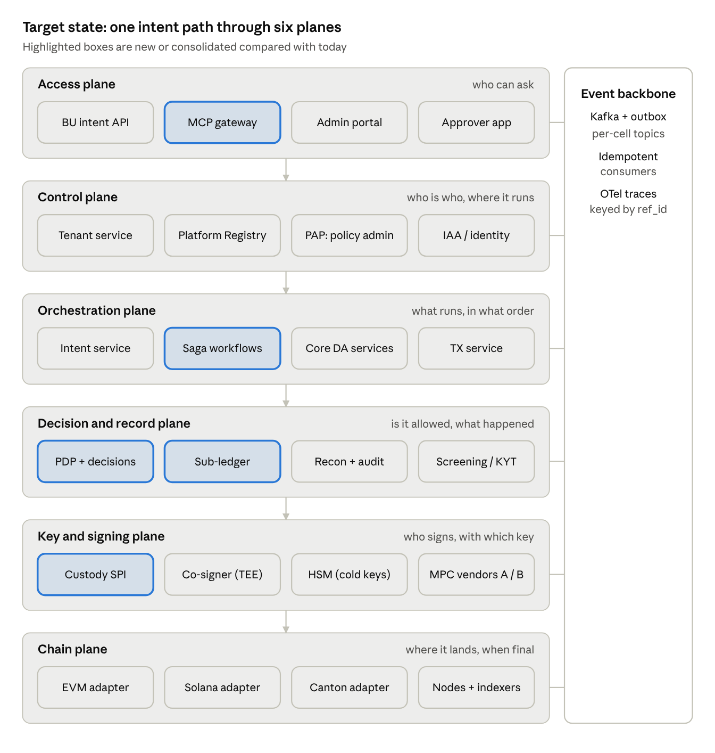
target-state DAP · six planes + event backbone
Read top to bottom: an intent enters through the access plane, is routed and orchestrated, approved by one PDP and recorded in the sub-ledger, then signed behind the custody SPI and landed by a chain adapter; every plane emits to the shared event backbone.

Scaling strategy
- Cells, not one big cluster. Each shard (BU × environment × region) is a cell with its own databases, Kafka topics and co-signers. A cell failure or noisy BU never affects another. New BUs mean new cells, not bigger ones.
- Control plane / data plane split. Tenant, registry, PAP and IAA are low-QPS control plane; routing snapshots and policy bundles are pushed to the data plane so hot paths make no synchronous control-plane calls.
- Async by default. Callers get ref_id immediately; status flows by event or callback. Synchronous paths only for reads and dry-run policy.
- Durable orchestration. Sagas (tokenization, onboarding, cross-shard settlement) on a workflow engine give retries, timers, compensation and visibility for free.
- Chain adapters as plugins. One adapter per chain family (EVM, SVM, Canton, UTXO) implementing build, decode, simulate, finality and fee estimation. Adding a chain = one adapter + one custody-provider capability flag.
- Own node and indexer infrastructure for read paths (balances, events, simulation) instead of relying solely on the vendor, which also gives an independent view for reconciliation.
- Multi-region. Active-active per jurisdiction, with X-Region as an explicit bridge carrying signed intents, never replicated keys.

NFR targets and phased roadmap
These are proposed starting targets to validate with product, SRE and risk (Q22); none are agreed figures.
Capability | Proposed target | Measured at
API availability (read + intent intake) | 99.95% per cell | Ingress
Signing-path availability | 99.9% per cell | Co-signer + vendor
Intent acceptance latency | p99 < 300 ms | Gateway to ref_id returned
Policy decision latency | p99 < 50 ms | PDP
Co-signer callback added latency | p99 < 500 ms incl. simulation | Co-signer
Ledger RPO / RTO | 0 / 15 min | Sub-ledger
Signing RTO after region loss | < 1 h | DR drill
Reconciliation breaks | 0 unexplained after T+1 | Recon job
Audit retention | Per records policy, WORM | Audit store
The roadmap runs in four phases, each gated on evidence rather than dates.
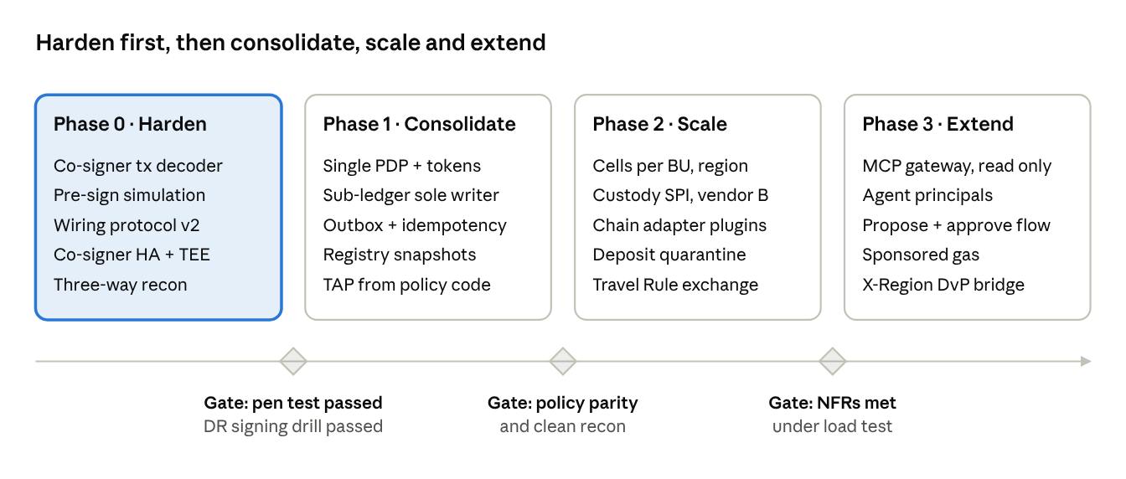
proposed roadmap · 4 phases, 3 gates
Phase 0 closes the asset-safety gaps (F2, F3, F9, F15) before any re-platforming; agentic MCP access comes last, once policy and ledger are consolidated.

Q&A round: questions for the team
Thirty questions to close the gaps I could not resolve from the page; answers fill the right-hand column and may retire or reshape findings.

Keys, MPC and signing
# | Question | Why it matters | Answer
Q1 | What is the threshold scheme per workspace, and can Fireblocks + any non-MS party sign without the MS co-signer? | Defines whether MS holds a real veto
Q2 | Is the co-signer key share in HSM, TEE, or plain memory today? Who can access the host? | Co-signer is the bank's main control (F9)
Q3 | What is the co-signer HA model and measured signing RTO? | Liveness dependency on every tx
Q4 | Who holds the recovery kit, under what dual control, and when was the last recovery drill? | Regulatory and DR evidence
Q5 | How are Canton keys handled — MPC, HSM, or participant node? | Canton differs from EVM/Solana signing
Q6 | Does the co-signer decode and simulate Tr independently, or trust Fireblocks' parsed fields? | WYSIWYS (F2)

Policy
# | Question | Why it matters | Answer
Q7 | Which policy engine backs Policy Service (OPA, Cedar, custom)? Are policies versioned and signed? | Consolidation path (F1)
Q8 | What does each of business, platform and signing policy check that the others do not? | Find overlaps and gaps
Q9 | How is TAP kept in sync with MS policy? Manual or generated? | Drift between layers
Q10 | How long is a verdict valid, and is it bound to a hash of the tx it approved? | TOCTOU
Q11 | Who can change policy, with what approval, and is there a policy test suite? | Change-risk governance

Wiring protocol and security
# | Question | Why it matters | Answer
Q12 | Why RS256 rather than Ed25519/P-256? Where are signing keys held, and how rotated? | Performance, key mgmt
Q13 | How do we prevent replay of a signed message (no timestamp/nonce in headers)? | F3
Q14 | Is x-dap-msgtype bound into the signature anywhere? | Header substitution
Q15 | Is mTLS / workload identity used between services, or only message signatures? | Defense in depth
Q16 | Is x-dap-api-key JWT short-lived, and how is it revoked? | Credential compromise

Data, events and ledger
# | Question | Why it matters | Answer
Q17 | Which service is the system of record for balances — Token, Wallet, or Back Office? | F5
Q18 | Do services use a transactional outbox, and are consumers idempotent on ref_id? | F4
Q19 | What confirmation/finality rule is applied per chain, and how is a reorg reversed downstream? | Credit risk
Q20 | How is Kafka partitioned, and is per-account ordering guaranteed? | Consistency
Q21 | Is there a three-way recon (ledger / vendor / chain) today, and who owns breaks? | Audit

Tenancy, routing and scale
# | Question | Why it matters | Answer
Q22 | What are target TPS, p99 latency and number of shards for year 1 and year 3? | Sizing (F13)
Q23 | What are Fireblocks API rate limits per workspace, and have we load-tested against them? | Real bottleneck
Q24 | Is Platform Registry cached at the caller? What happens if it is down? | F7
Q25 | How does X-Region interact with data residency (e.g., EU vs US client data)? | Jurisdictional isolation

Vendor, compliance and roadmap
# | Question | Why it matters | Answer
Q26 | Is a second custody vendor or in-house signer planned? What is the exit plan from Fireblocks? | F6, concentration risk
Q27 | Where do sanctions screening, KYT and Travel Rule run, and are deposits quarantined? | F10
Q28 | What is the smart-contract upgrade and admin-role model for issued tokens? | F12
Q29 | What does "MCP wallet" mean to stakeholders — MPC custody, or AI-agent access via Model Context Protocol? | Scope of this work
Q30 | Which regulators and frameworks are in scope (e.g., OCC, NYDFS, SOC 2, internal tech risk), and what evidence do they expect? | Shapes audit design

Proposed next steps and spikes
I'd suggest starting with a Q&A session on Q1–Q21, then three short spikes that de-risk the high-priority findings before any re-architecture.
- ☐ Walk through this doc with the architecture owners; record answers in the Q&A tables
- ☐ Spike A — Co-signer WYSIWYS (F2): prototype EVM calldata decode + forked simulation inside the co-signer callback for an ERC-20 transfer and an ERC-3643 mint; measure added latency
- ☐ Spike B — Decision tokens (F1): model business + platform policy in OPA or Cedar for one flow; emit signed decision tokens bound to H(tx); have the co-signer verify the chain
- ☐ Spike C — Wiring protocol v2 (F3): extend signature base with service, msgtype, created, nonce, aud; benchmark Ed25519 vs RS256 verify on the dispatcher
- ☐ Draft the Custody Provider SPI interface (F6) and review against a second vendor's API
- ☐ Define the sub-ledger ownership decision (F5) as an ADR
- ☐ Agree NFR targets with product and SRE
- ☐ Confirm the meaning of "MCP wallet" (Q29) and, if agentic, write an MCP gateway threat model

